

**Sri Lanka Institute of Information Technology**

**Design Document – Lab Sheet 03**

**SE3050 – User Experience Engineering – 2021**

Group ID: 2021S1_JUNE_WD_09

Submitted by:

1. IT19962726– Kodithuwakku K.M.K.L
2. IT19973166– Kariyawasam H.G.P
3. IT19973098– Thathsarani R.P.G.T
4. IT19977508– Munasinghe D.D.S

|  |  |  |
| --- | --- | --- |
| ID Number | Name | Contribution |
| IT19962726 | Kodithuwakku K.M.K.L | persona 1, empathy map 1, user story 1, user flow 1, service blueprint |
| IT19973166 | Kariyawasam H.G.P | persona 2, empathy map 2, user story 2, user flow 2, service blueprint |
| IT19973098 | Thathsarani R.P.G.T | persona 3, empathy map 3, user story 3, user flow 3, service blueprint |
| IT19977508 | Munasinghe D.D.S | persona 4, empathy map 4, user story 4, user flow 4, service blueprint |

**Individual Contribution**

Contents

**Persona – 01** 4

**Empathy Map – 01** 5

**User Story – 01** 6

**User Flow - 01** 6

**Persona – 02** 7

**Empathy Map – 02** 8

**User Story – 02** 9

**User Flow - 02** 10

**Persona – 03** 11

**Empathy Map – 03** 12

**User Story – 03** 13

**User Flow - 03** 13

**Persona – 04** 14

**Empathy Map – 04** 15

**User Story – 04** 16

**User Flow - 04** 16

**Service Blueprint** 17

# **Persona – 01**

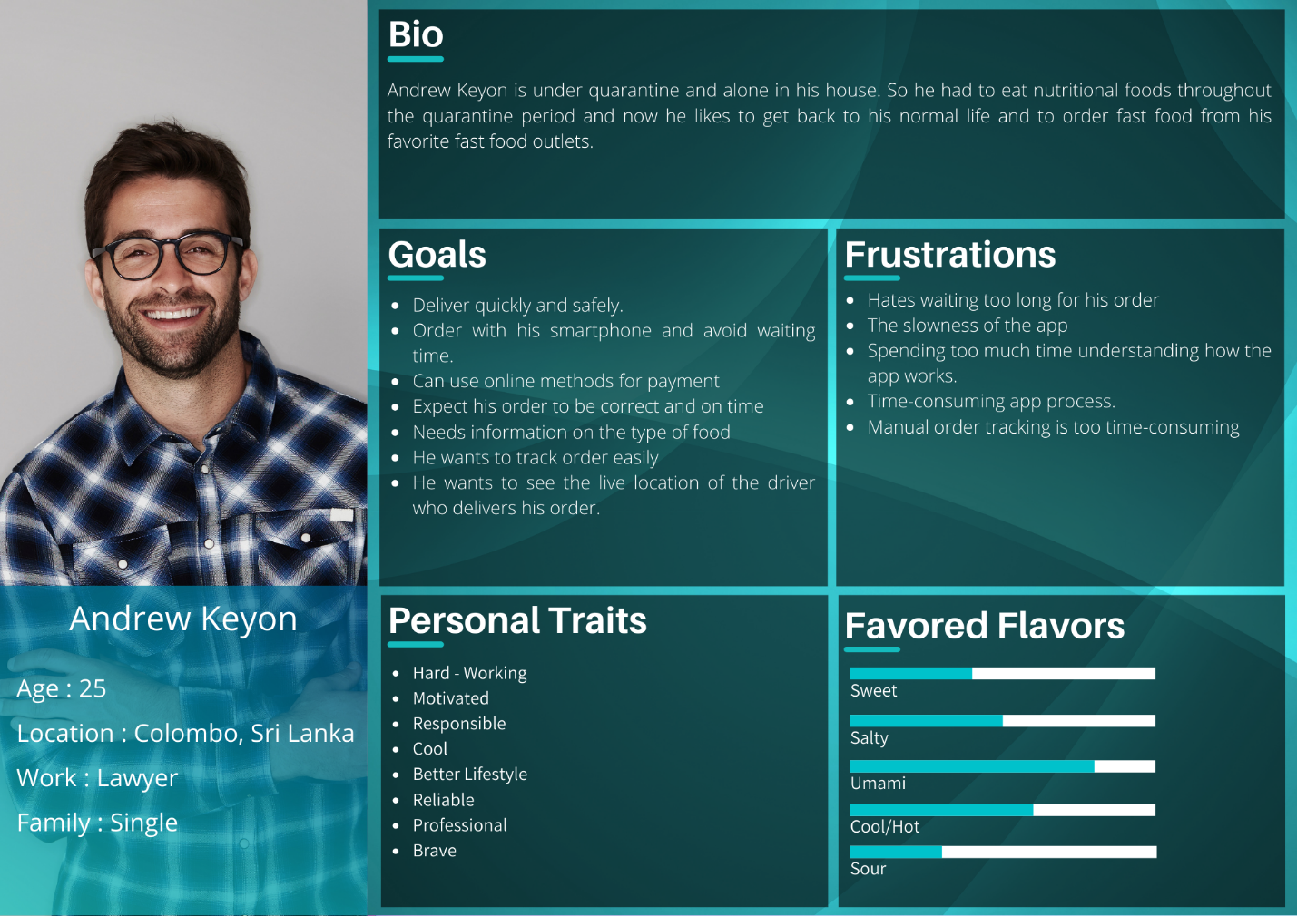

# **A picture containing timeline Description automatically generatedEmpathy Map – 01**

# **User Story – 01**

# **User Flow - 01**

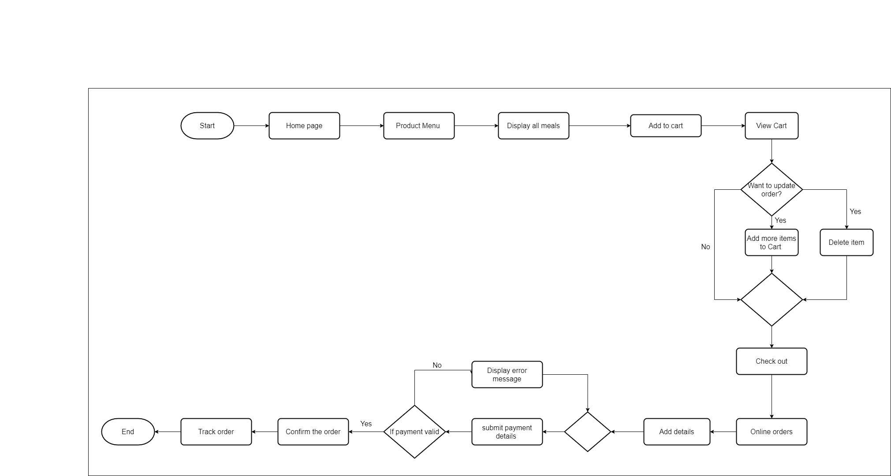

# **Persona – 02**

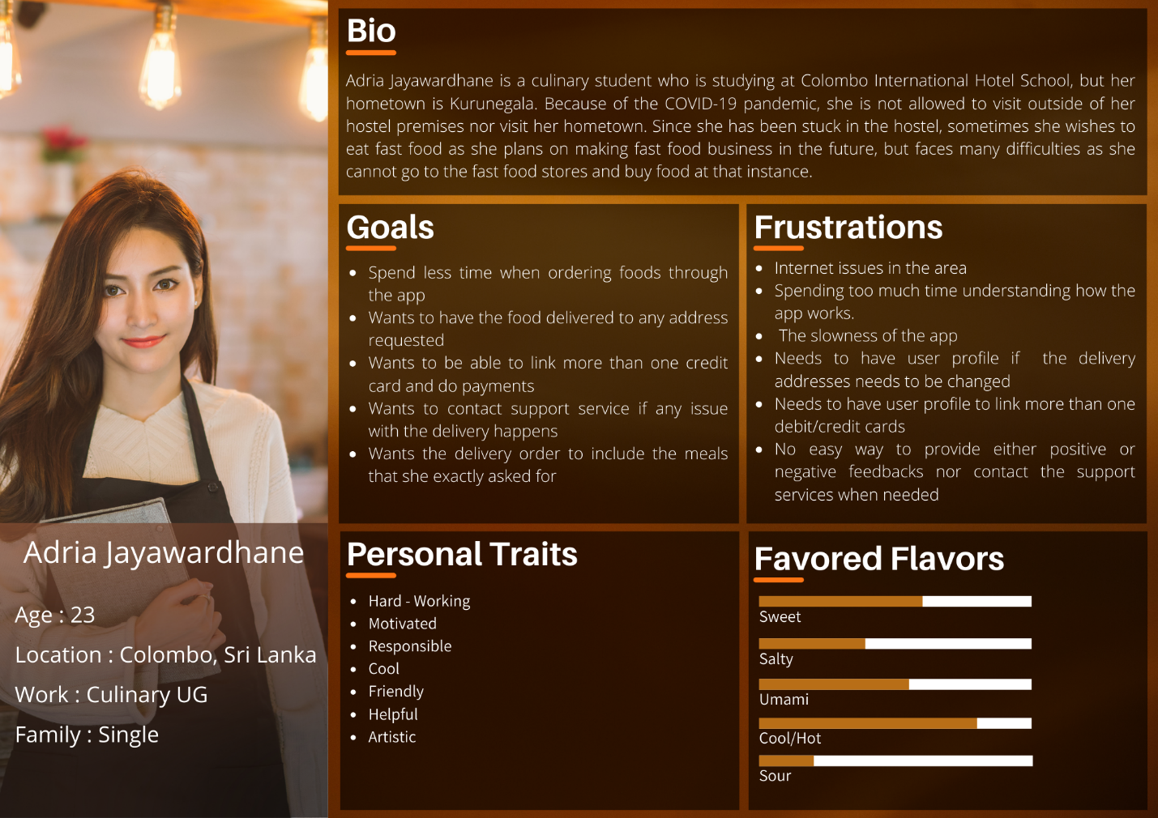

**Empathy Map – 02**

# **User Story – 02**

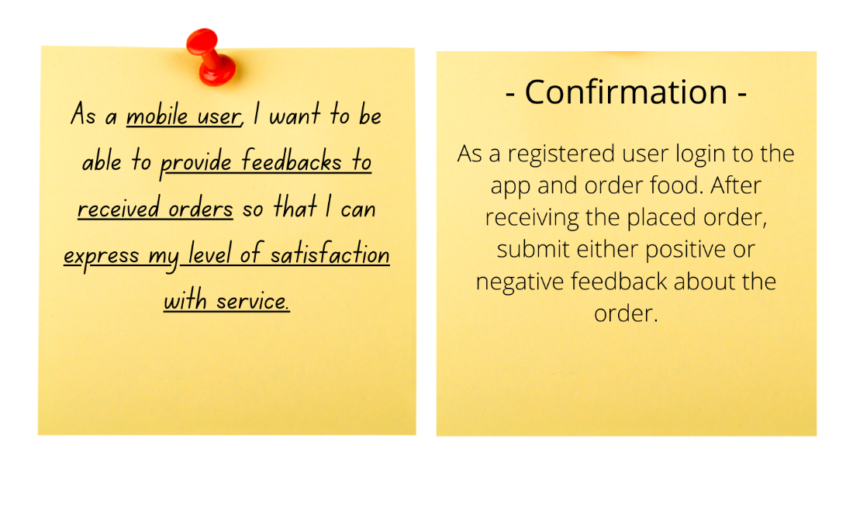

# **Diagram Description automatically generatedUser Flow - 02**

# **Persona – 03**

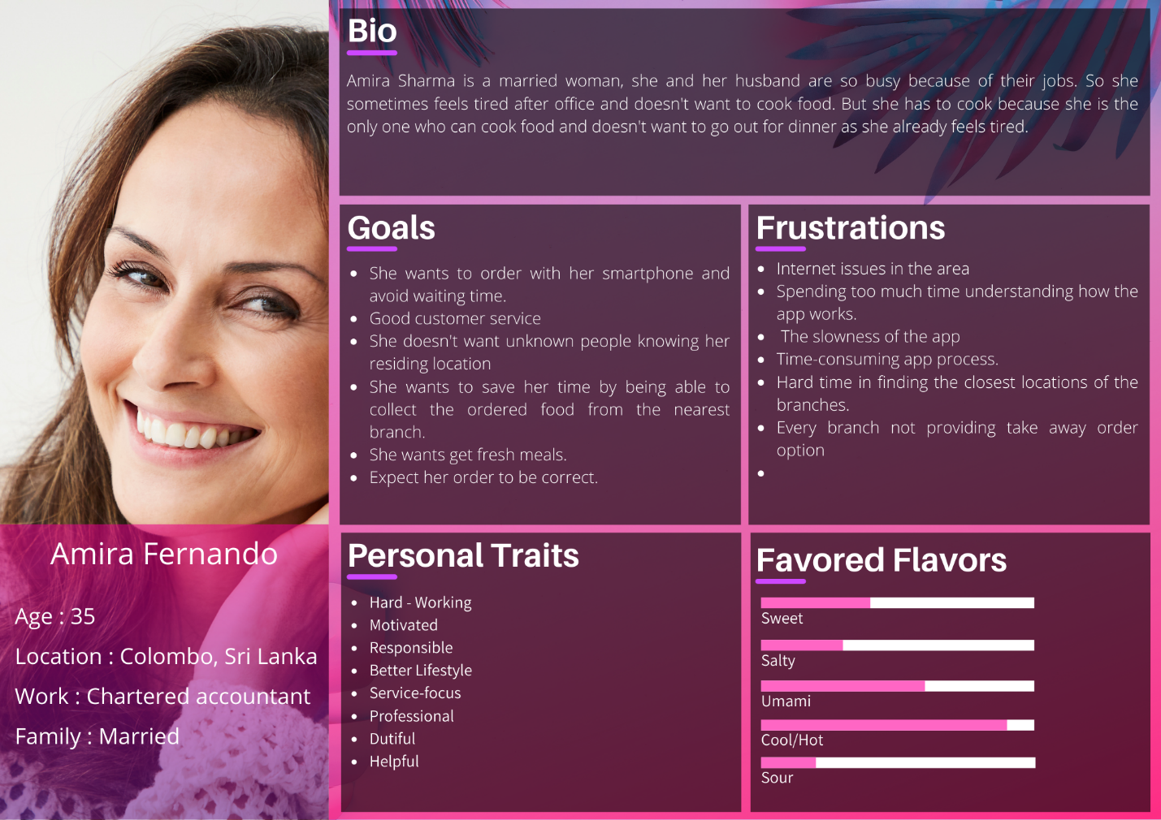

# **Graphical user interface Description automatically generatedEmpathy Map – 03**

# **User Story – 03**

# **User Flow - 03**

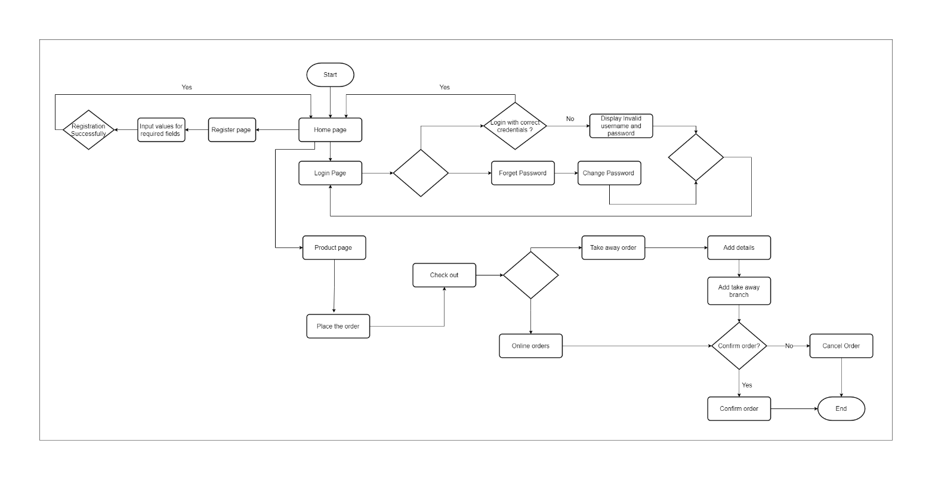

# **Persona – 04**

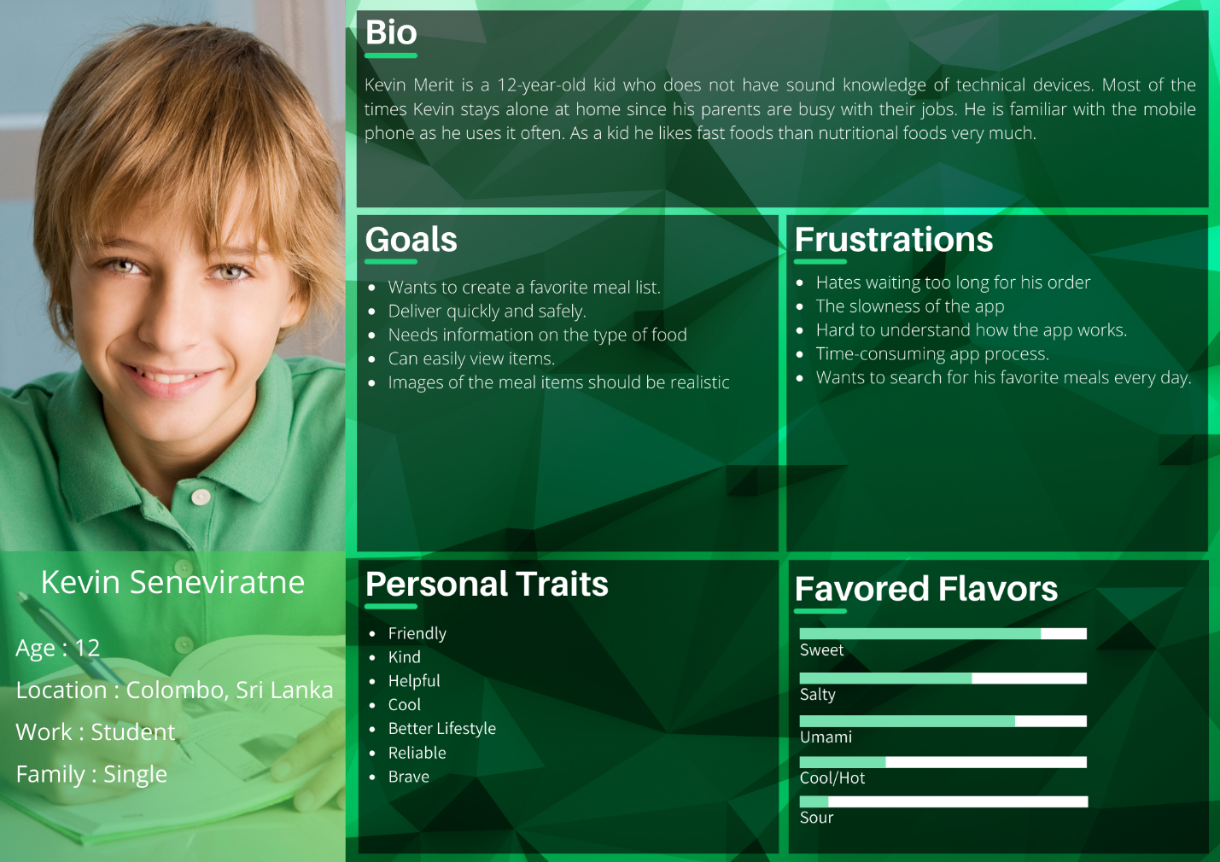

# **A picture containing graphical user interface Description automatically generatedEmpathy Map – 04**

# **User Story – 04**

# **Diagram Description automatically generatedUser Flow - 04**

# **Graphical user interface, timeline Description automatically generated Service Blueprint**